# 

# 

# 

# PATAN COLLEGE FOR PROFESSIONAL STUDIES

# Individual Reflective Report

# Python Project

# 

# Shahu: The Ultimate Shared Power

# PROJECT REPORT

# Submitted by Submitted to

# Ram Ghimire (1816707) UOB

**Individual report**

This form is submitted by every member of your group and used to assess the level of teamwork in your group and the contribution of individuals. It may also form the basis of discussions which affect the grades received by individual group members.

|  |  |  |  |
| --- | --- | --- | --- |
| Student Number | First Name | Last Name | Group No |
| 1816707 | Ram | Ghimire | 10 |

I feel amazing while being in this group. Before joining this faculty, I was not from computer background but still my dream followed me to get admission on this University of Bedfordshire. Being a student of world rank university I knew there will be lots of group projects , in this SEM-I of level 4 , python project was assigned for us during this semester I would like to make you clear that this project was little bit tough however having a group members like Kshitij Bajagain, Dinesh Timalsina , Anupam Dhakal .Introduction to software development project was assigned and being a member of this group I did following work as mentioned in work division and I worked as analyst during the whole software development.

|  |  |  |
| --- | --- | --- |
| **S. N** | **Name** | **Work Division** |
| **1.** | Kshitij Bajagain | Brainstorms, User Panel ,Upload Tools , Search Tools,, Hire Tools, Class Diagram, File handling(FH) |
| **2.** | Anupam Dhakal | Research, Login , Register, UML Diagrams(Sea level, Fish Level), Presentation Slides |
| **3.** | Dinesh Timalsina | Return Tools, Payment , Invoice Generation, Clam level Diagram, Testing of software |
| **4.** | Ram Prasad Ghimire | Insurance agent profile design and development, Activity diagram, Analysis of software |

Above mentioned work division is so clear, and every member worked according to this and I would like to show my work that I did in this individual reflective report. Above mentioned works are mentioned below:

1. **Activity Diagram**:

I successfully did the activity diagram on the basis use case and class diagram. Making a UML is always a challenging but having proper co-ordination with team members I successfully completed my task

1. **Insurance Agent functions:**

Insurance agent profile was mentioned in UML diagrams, I successfully did this task assigned to me.

1. **Analysis of software:**

This is the major part of software development. As without any analysis, software cannot be developed because analysis helps to develop the possible outcomes needed for initial phase of development.

Working with team is always a life time achievement, having a team members like Anupam Dhakal, Dinesh Timalsina and Kshitij Bajagain is a achievement for me. I would like to show gratitude towards my team members on motivating me to work and complete my part as mentioned above in group division table. Evaluating work done by my team members was pretty hard job because they have did everything so much clearly but still there were some confusion regarding the software development in initial phase but after co-ordination everything went good for us. Following tables consist of rating for every individual during software development.

|  |  |  |  |
| --- | --- | --- | --- |
| Student Number | First Name | Last Name | Contribution  (N,S,I) |
| 1815429 | Dinesh | Timalsina | S |
| 1723333 | Kshitij | Bajagain | S |
| 1815430 | Anupam | Dhakal | S |

**S** -Significant (The group member’s work was integral to the overall submission)

**N** -No Contribution (The group member took no part in the project submission)

**I** -Insignificant (The group member’s work made little difference to the overall submission)

After getting some advice from supervisor and HOD my group worked hardly and developed an awesome software which was the main regarding the development phase. Confusion was about diagrams, we were able to produce diagrams at time but there were some difficulties. But our supervisor helped us and made the diagrams error free.

Team work along some proper co-ordination produced this amazing software. I like to show full gratitude towards my team member Dinesh Timalsina, Kshitij Bajagain and Anupam Dhakal is an achievement for me. I love the way how the presentation along with software development went; I will like to thank my ISD supervisor bishwokiran bhhatrai, HOD Dr. Swati shah, and Dean of academics Ajaya Sharma for motivating me to complete assigned task. After completion of this project, I am motivated to do more in upcoming projects and be more competitive and make more software in upcoming future. We have dedicated our software to those tradesmen who were unable to buy expensive tools. We as group feel proud of ourselves on completing this project and we are more motivated to develop such projects in upcoming future.

1. **Activity Diagram**:

This is activity diagram which I did during software development phase.

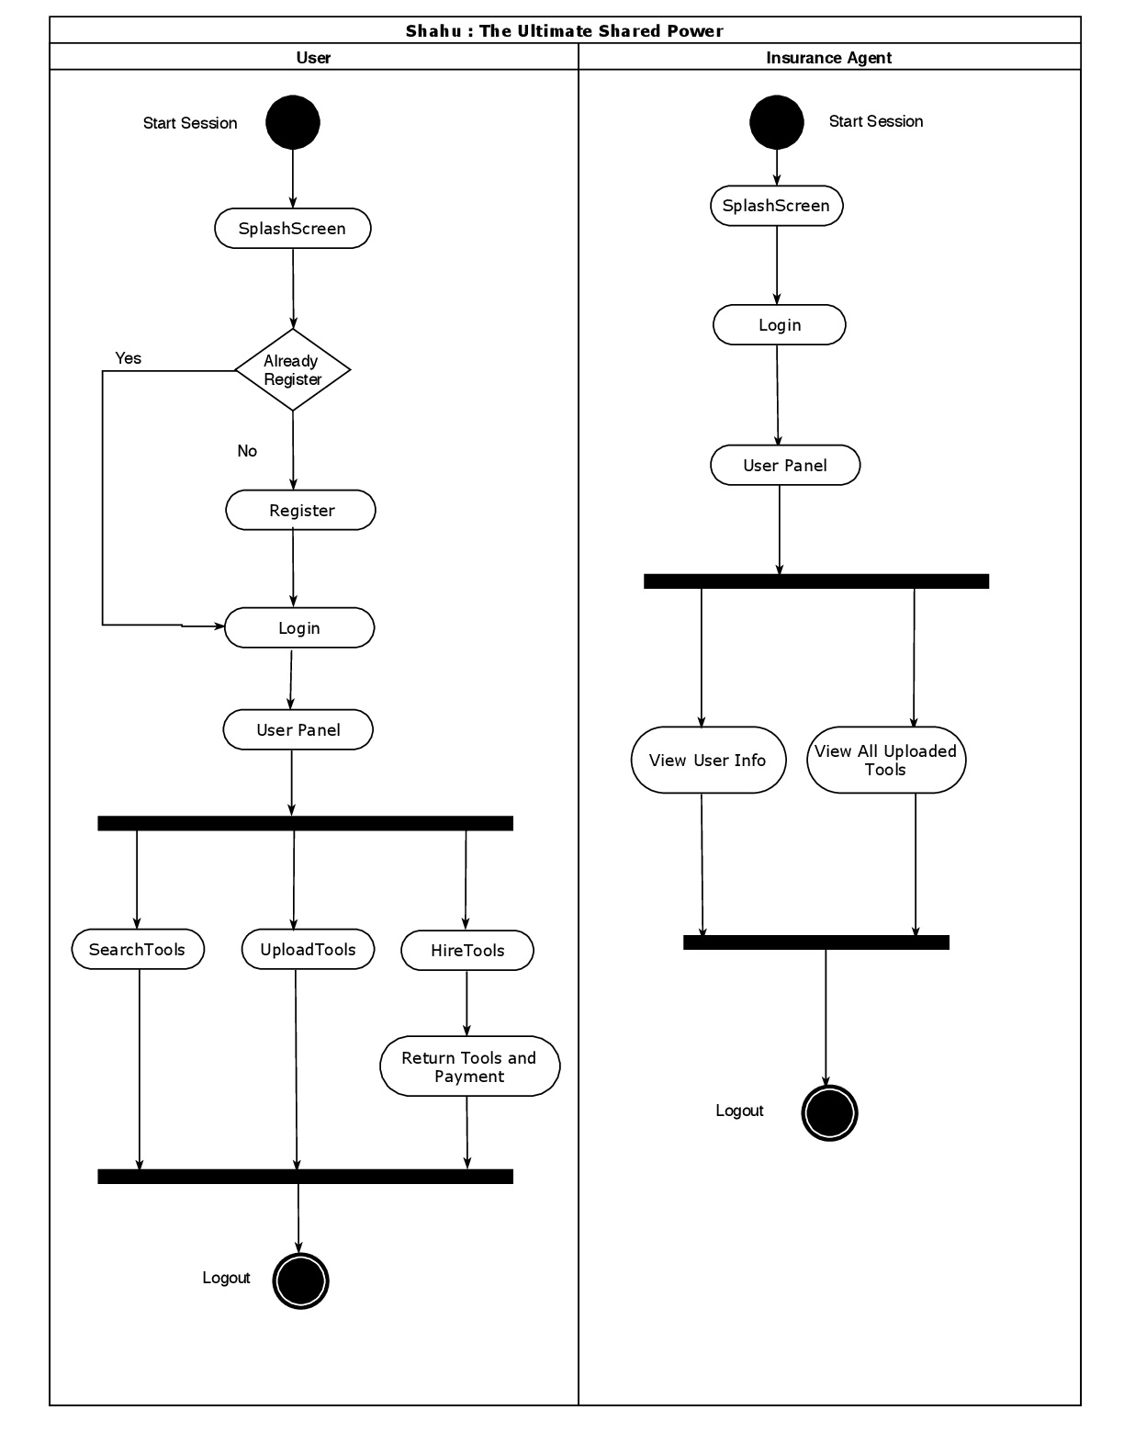

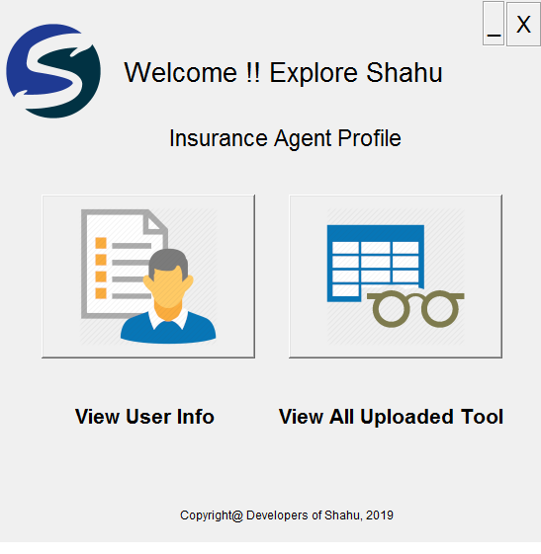**2>Development**

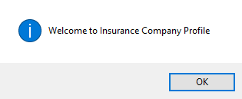

**Validation Check**

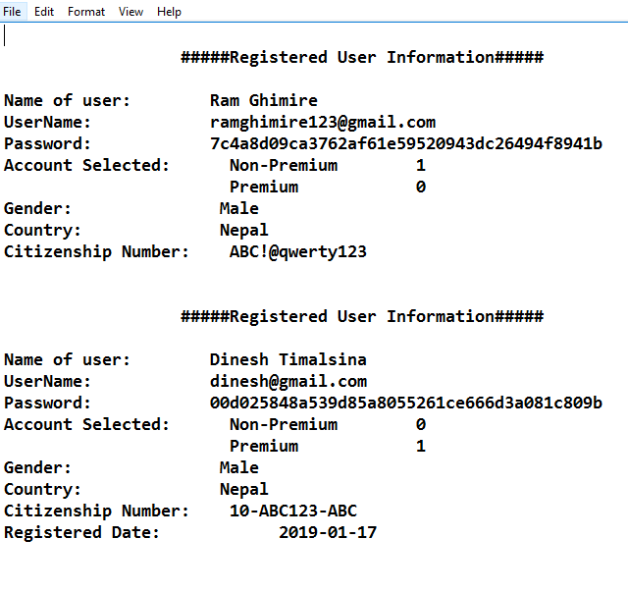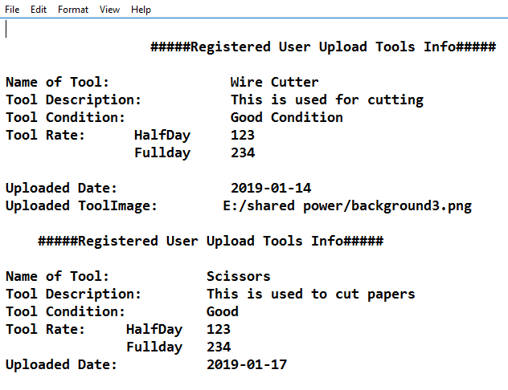

**Registered User Info Uploaded Tool Info**

**Code Snippets:**

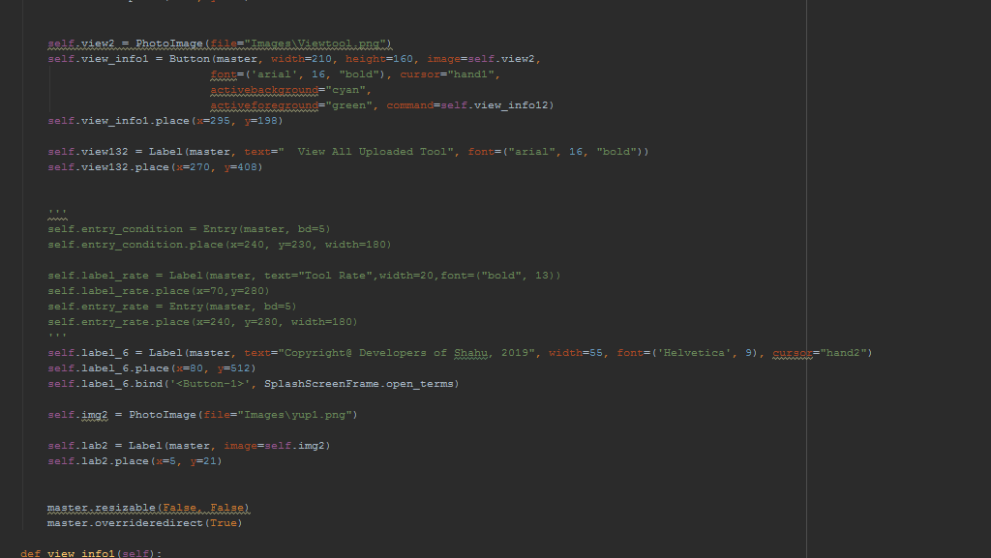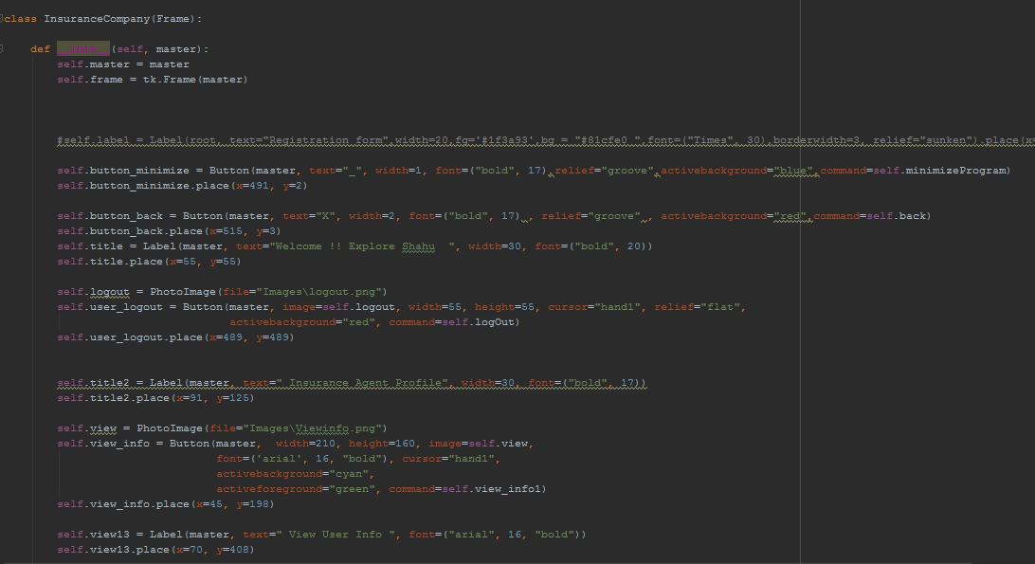

**This is the snippets of code which are shown ..Complete code is shown in group report.**